# Chapter 5: RISK MANAGEMENT

Risk management is the process of identifying, assessing and controlling the threats throughout the project. It helps to reduce the risks that might influence in the success of the project. There are steps, which helps to minimize the risk, are as follows:

* Risk evaluation
* Risk assessment/analysis
* Risk handling
* Risk monitoring

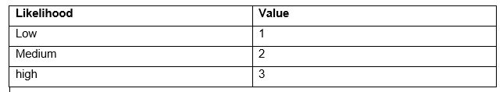

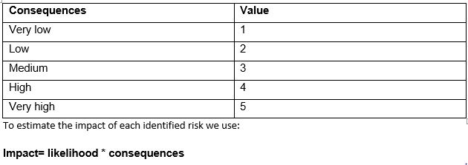

|  |  |  |  |  |  |  |
| --- | --- | --- | --- | --- | --- | --- |
| **Risk ID** | **Risk** | **Likelihood** | **Consequences** | **Impact** | **Action** | **Remarks** |
|  | System Failure | 2 | 3 | 6 | Backup for the system should be daily maintain |  |
|  | Poor project planning | 2 | 4 | 8 | Plan should be done on the basis of following methodology |  |
|  | Server crash | 1 | 4 | 4 | Back up should be done on daily basis |  |
|  | Change of requirements | 3 | 3 | 9 | Project must be adaptable to adjust in changes in requirements. |  |
|  | Data security | 2 | 4 | 8 | Use antiviruses, firewall for the unauthorized access |  |
|  | Not being prepared before the project begins | 1 | 4 | 4 | Know the goals of website, known the functional requirements. |  |